***University Physics Volume 1***

**Unit 1: Mechanics**

**Chapter 8: Potential Energy and Conservation of Energy**

**Conceptual Questions**

1. The kinetic energy of a system must always be positive or zero. Explain whether this is true for the potential energy of a system.

Solution

The potential energy of a system can be negative because its value is relative to a defined point.

1. The force exerted by a divingboard is conservative, provided the internal friction is negligible. Assuming friction is negligible, describe changes in the potential energy of a diving board as a swimmer drives from it, starting just before the swimmer steps on the board until just after his feet leave it.

Solution

The diving board goes through changes of both gravitational potential energy and elastic potential energy. For gravitational potential energy, there is a change as the diving board angles downward as the diver puts pressure on the end of the board. The gravitational potential energy gets smaller below the diving board. If the elastic potential energy is set to zero when the board is at an equilibrium position, the elastic potential energy increases as the board is pressed downward by the diver and as it returns to its original distance, the elastic potential energy returns to zero.

1. Describe the gravitational potential energy transfers and transformations for a javelin, starting from the point at which an athlete picks up the javelin and ending when the javelin is stuck into the ground after being thrown.

Solution

If the reference point of the ground is zero gravitational potential energy, the javelin first increases its gravitational potential energy, followed by a decrease in its gravitational potential energy as it is thrown until it hits the ground. The overall change in gravitational potential energy of the javelin is zero unless the center of mass of the javelin is lower than from where it is initially thrown, and therefore would have slightly less gravitational potential energy.

1. A couple of soccer balls of equal mass are kicked off the ground at the same speed but at different angles. Soccer ball A is kicked off at an angle slightly above the horizontal, whereas ball B is kicked slightly below the vertical. How do each of the following compare for ball A and ball B? (a) The initial kinetic energy and (b) the change in gravitational potential energy from the ground to the highest point? If the energy in part (a) differs from part (b), explain why there is a difference between the two energies.

Solution

a. same kinetic energies; b. The slightly above the horizontally kicked ball will have a much smaller change in gravitational potential energy than the nearly vertical ball.

1. What is the dominant factor that affects the speed of an object that started from rest down a frictionless incline if the only work done on the object is from gravitational forces?

Solution

the vertical height from the ground to the object

1. Two people observe a leaf falling from a tree. One person is standing on a ladder and the other is on the ground. If each person were to compare the energy of the leaf observed, would each person find the following to be the same or different for the leaf, from the point where it falls off the tree to when it hits the ground: (a) the kinetic energy of the leaf; (b) the change in gravitational potential energy; (c) the final gravitational potential energy?

Solution

a. The kinetic energy observed will be the same regardless of who is observing the leaf falling. b. the change in gravitational potential energy depends on the work done on the leaf. Since this is the same regardless of observers, the answers will be the same. c. The final gravitational potential energy depends on the reference point. Assuming the same reference point for both observers will still result in different values of the final gravitational potential energy.

1. What is the physical meaning of a non-conservative force?

Solution

A force that takes energy away from the system that can’t be recovered if we were to reverse the action.

1. A bottle rocket is shot straight up in the air with a speed . If the air resistance is ignored, the bottle would go up to a height of approximately . However, the rocket goes up to only  before returning to the ground. What happened? Explain, giving only a qualitative response.

Solution

A non-conservative force such as air resistance must have been present in this situation.

1. An external force acts on a particle during a trip from one point to another and back to that same point. This particle is only effected by conservative forces. Does this particle’s kinetic energy and potential energy change as a result of this trip?

Solution

The change in kinetic energy is the net work. Since conservative forces are path independent, when you are back to the same point the kinetic and potential energies are exactly the same as the beginning. During the trip the total energy is conserved, but both the potential and kinetic energy change.

1. When a body slides down an inclined plane, does the work of friction depend on the body’s initial speed? Answer the same question for a body sliding down a curved surface.

Solution

The work done by friction depends on the frictional force and the distance it travels, so it doesn’t depend on the initial speed in either case, but the frictional force changes with changes in the normal force, which happens on a curved path.

1. Consider the following scenario. A car for which friction is *not* negligible accelerates from rest down a hill, running out of gasoline after a short distance (see below). The driver lets the car coast farther down the hill, then up and over a small crest. He then coasts down that hill into a gas station, where he brakes to a stop and fills the tank with gasoline. Identify the forms of energy the car has, and how they are changed and transferred in this series of events.

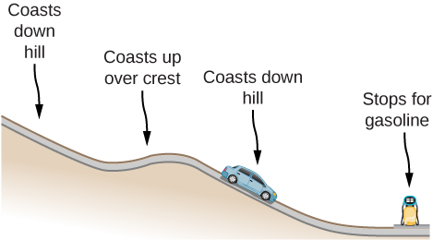

Solution

The car experiences a change in gravitational potential energy as it goes down the hills because the vertical distance is decreasing. Some of this change of gravitational potential energy will be taken away by work done by friction. The rest of the energy results in a kinetic energy increase, making the car go faster. Lastly, the car brakes and will lose its kinetic energy to the work done by braking to a stop.

1. A dropped ball bounces to one-half its original height. Discuss the energy transformations that take place.

Solution

Energy transforms from gravitational potential energy to kinetic energy and back to gravitational potential energy, albeit a lower amount of energy. The loss of gravitational potential energy is due to heat and is lost to non-conservative, dissipative forces.

1. “constant is a special case of the work-energy theorem.” Discuss this statement.

Solution

It states that total energy of the system *E* is conserved as long as there are no non-conservative forces acting on the object.

1. In a common physics demonstration, a bowling ball is suspended from the ceiling by a rope.

The professor pulls the ball away from its equilibrium position and holds it adjacent to his nose, as shown below. He releases the ball so that it swings directly away from him. Does he get struck by the ball on its return swing? What is he trying to show in this demonstration?

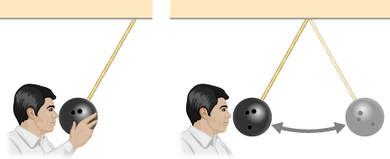

Solution

He does not get struck by the ball since the energy he provides to the ball can only stay the same or decrease if there is non-conservative work being done on the ball. Therefore, the ball will either return to the same position or end slightly closer to the equilibrium position of the pendulum.

1. A child jumps up and down on a bed, reaching a higher height after each bounce. Explain how the child can increase his maximum gravitational potential energy with each bounce.

Solution

He puts energy into the system through his legs compressing and expanding.

1. Can a non-conservative force increase the mechanical energy of the system?

Solution

Non-conservative forces take energy away from the system and therefore do not increase the mechanical energy of the system.

1. Neglecting air resistance, how much would I have to raise the vertical height if I wanted to double the impact speed of a falling object?

Solution

Four times the original height would double the impact speed.

1. A box is dropped onto a spring at its equilibrium position. The spring compresses with the box attached and comes to rest. Since the spring is in the vertical position, does the change in the gravitational potential energy of the box while the spring is compressing need to be considered in this problem?

Solution

In general, yes, the change in gravitational potential energy needs to be considered for both when the box falls to the spring and the distance the spring compresses. However, if the weight of the object is much less than half of the spring constant (considering the gravitational potential energy vs. the elastic potential energy), this term may be neglected and the answer will still be correct.

**Problems**

1. Using values from this table, how many DNA molecules could be broken by the energy carried by a single electron in the beam of an old-fashioned TV tube? (These electrons were not dangerous in themselves, but they did create dangerous X-rays. Later-model tube TVs had shielding that absorbed X-rays before they escaped and exposed viewers.)

|  |  |
| --- | --- |
| Object/phenomenon | Energy in joules |
| Big Bang |  |
| Annual world energy use |  |
| Large fusion bomb (9 megaton) |  |
| Hiroshima-size fission bomb (10 kiloton) |  |
| 1 barrel crude oil |  |
| 1 ton TNT |  |
| 1 gallon of gasoline |  |
| Daily adult food intake (recommended) |  |
| 1000-kg car at 90 km/h |  |
| Tennis ball at 100 km/h |  |
| Mosquito |  |
| Single electron in a TV tube beam |  |
| Energy to break one DNA strand |  |

Solution

40,000

1. If the energy in fusion bombs were used to supply the energy needs of the world, how many of the 9-megaton variety would be needed for a year’s supply of energy (using data from the following table)?

|  |  |  |  |
| --- | --- | --- | --- |
|  | Gravitational P.E. | Elastic P.E. | Kinetic E. |
| (3) Highest Point |  |  |  |
| (2) Equilibrium |  |  |  |
| (1) Lowest Point |  |  |  |

Solution

10,000

1. A camera weighing 10 N falls from a small drone hovering  overhead and enters free fall. What is the gravitational potential energy change of the camera from the drone to the ground if you take a reference point of (a) the ground being zero gravitational potential energy? (b) The drone being zero gravitational potential energy? What is the gravitational potential energy of the camera (c) before it falls from the drone and (d) after the camera lands on the ground if the reference point of zero gravitational potential energy is taken to be a second person looking out of a building from the ground?

Solution



1. Someone drops a pebble off of a docked cruise ship,  from the water line. A person on a dock  from the water line holds out a net to catch the pebble. (a) How much work is done on the pebble by gravity during the drop? (b) What is the change in the gravitational potential energy during the drop? If the gravitational potential energy is zero at the water line, what is the gravitational potential energy (c) when the pebble is dropped? (d) When it reaches the net? What if the gravitational potential energy was Joules at water level? (e) Find the answers to the same questions in (c) and (d).

Solution



1. A cat’s crinkle ball toy of mass  is thrown straight up with an initial speed of . Assume in this problem that air drag is negligible. (a) What is the kinetic energy of the ball as it leaves the hand? (b) How much work is done by the gravitational force during the ball’s rise to its peak? (c) What is the change in the gravitational potential energy of the ball during the rise to its peak? (d) If the gravitational potential energy is taken to be zero at the point where it leaves your hand, what is the gravitational potential energy when it reaches the maximum height? (e) What if the gravitational potential energy is taken to be zero at the maximum height the ball reaches, what would the gravitational potential energy be when it leaves the hand? (f) What is the maximum height the ball reaches?

Solution



1. A force  acts on a particle as it moves along the positive *x*-axis. (a) How much work does the force do on the particle as it moves from  to  (b) Picking a convenient reference point of the potential energy to be zero at  find the potential energy for this force.

Solution



1. A force  acts on a particle. How much work does the force do on the particle as it moves from  to 

Solution



1. Find the force corresponding to the potential energy 

Solution



1. The potential energy function for either one of the two atoms in a diatomic molecule is often approximated by  where *x* is the distance between the atoms. (a) At what distance of separation does the potential energy have a local minimum (not at (b) What is the force on an atom at this separation? (c) How does the force vary with the separation distance?

Solution

a.  ; b. ; c. 

1. A particle of mass 2.0 kg moves under the influence of the force  If its speed at is  what is its speed at 

Solution



1. A particle of mass 2.0 kg moves under the influence of the force  If its speed at  is  what is its speed at 

Solution



1. A crate on rollers is being pushed without frictional loss of energy across the floor of a freight car (see the following figure). The car is moving to the right with a constant speed  If the crate starts at rest relative to the freight car, then from the work-energy theorem,  where *d*, the distance the crate moves, and *v*, the speed of the crate, are both measured relative to the freight car. (a) To an observer at rest beside the tracks, what distance  is the crate pushed when it moves the distance *d* in the car? (b) What are the crate’s initial and final speeds  and as measured by the observer beside the tracks? (c) Show that  and, consequently, that work is equal to the change in kinetic energy in both reference systems.

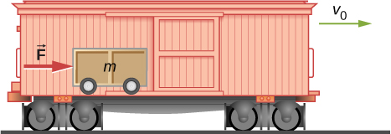

Solution

a. ; b. ; c. proof

1. A boy throws a ball of mass  straight upward with an initial speed of  When the ball returns to the boy, its speed is  How much much work does air resistance do on the ball during its flight?

Solution



1. A mouse of mass 200 g falls 100 m down a vertical mine shaft and lands at the bottom with a speed of 8.0 m/s. During its fall, how much work is done on the mouse by air resistance?

Solution

–190 J

1. Using energy considerations and assuming negligible air resistance, show that a rock thrown from a bridge 20.0 m above water with an initial speed of 15.0 m/s strikes the water with a speed of 24.8 m/s independent of the direction thrown. (*Hint:* show that 

Solution

proof

1. A 1.0-kg ball at the end of a 2.0-m string swings in a vertical plane. At its lowest point the ball is moving with a speed of 10 m/s. (a) What is its speed at the top of its path? (b) What is the tension in the string when the ball is at the bottom and at the top of its path?

Solution



1. Ignoring details associated with friction, extra forces exerted by arm and leg muscles, and other factors, we can consider a pole vault as the conversion of an athlete’s running kinetic energy to gravitational potential energy. If an athlete is to lift his body 4.8 m during a vault, what speed must he have when he plants his pole?

Solution



1. Tarzan grabs a vine hanging vertically from a tall tree when he is running at  (a) How high can he swing upward? (b) Does the length of the vine affect this height?

Solution

a. meters higher than the starting point; b. The length of the vine does not affect this height.

1. Assume that the force of a bow on an arrow behaves like the spring force. In aiming the arrow, an archer pulls the bow back 50 cm and holds it in position with a force of . If the mass of the arrow is  and the “spring” is massless, what is the speed of the arrow immediately after it leaves the bow?

Solution



1. A man is skiing across level ground at a speed of when he comes to the small slope 1.8 m higher than ground level shown in the following figure. (a) If the skier coasts up the hill, what is his speed when he reaches the top plateau? Assume friction between the snow and skis is negligible. (b) What is his speed when he reaches the upper level if an  frictional force acts on the skis?

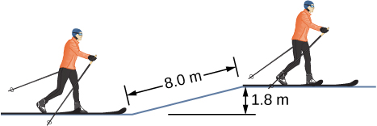

Solution



1. A sled of mass 70 kg starts from rest and slides down a incline long. It then travels for 20 m horizontally before starting back up an  incline. It travels 80 m along this incline before coming to rest. What is the magnitude of the net work done on the sled by friction?

Solution

1900 J

1. A girl on a skateboard (total mass of 40 kg) is moving at a speed of 10 m/s at the bottom of a long ramp. The ramp is inclined at  with respect to the horizontal. If she travels 14.2 m upward along the ramp before stopping, what is the net frictional force on her?

Solution

6.6 N

1. A baseball of mass 0.25 kg is hit at home plate with a speed of 40 m/s. When it lands in a seat in the left-field bleachers a horizontal distance 120 m from home plate, it is moving at 30 m/s. If the ball lands 20 m above the spot where it was hit, how much work is done on it by air resistance?

Solution

–39 J

1. A small block of mass *m* slides without friction around the loop-the-loop apparatus shown below. (a) If the block starts from rest at *A*, what is its speed at *B*? (b) What is the force of the track on the block at *B*?

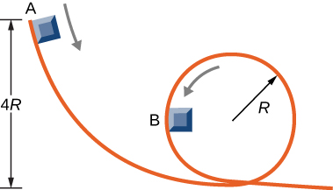

Solution

a.; b. 

1. The massless spring of a spring gun has a force constant  When the gun is aimed vertically, a 15-g projectile is shot to a height of 5.0 m above the end of the expanded spring. (See below.) How much was the spring compressed initially?

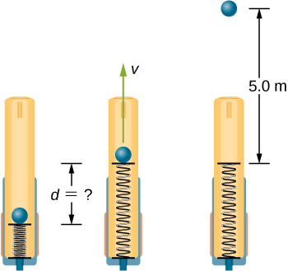

Solution

3.5 cm

1. A small ball is tied to a string and set rotating with negligible friction in a vertical circle. If the ball moves over the top of the circle at its slowest possible speed (so that the tension in the string is negligible), what is the tension in the string at the bottom of the circle, assuming there is no additional energy added to the ball during rotation?

Solution

At top: ;

At bottom using conservation of energy and our solution above:



Therefore the tension at the bottom of the string is:



1. A mysterious constant force of 10 N acts horizontally on everything. The direction of the force is found to be always pointed toward a wall in a big hall. Find the potential energy of a particle due to this force when it is at a distance *x* from the wall, assuming the potential energy at the wall to be zero.

Solution

10*x* with *x*-axis pointed away from the wall and origin at the wall

1. A single force  (in newtons) acts on a 1.0-kg body. When  the speed of the body is 4.0 m/s. What is its speed at 

Solution

7.0 m/s

1. A particle of mass 4.0 kg is constrained to move along the *x*-axis under a single force  where  The particle’s speed at *A*, where  is 6.0 m/s. What is its speed at *B*, where 

Solution

4.6 m/s

1. The force on a particle of mass 2.0 kg varies with position according to  (*x* in meters, *F*(*x*) in newtons). The particle’s velocity at  is 5.0 m/s. Calculate the mechanical energy of the particle using  (a) the origin as the reference point and (b)  as the reference point. (c) Find the particle’s velocity at  Do this part of the problem for each reference point.

Solution

a. 33 J; b. –31 J; c. 5.7 m/s

1. A 4.0-kg particle moving along the *x*-axis is acted upon by the force whose functional form appears below. The velocity of the particle at  is  Find the particle’s speed at  Does the particle turn around at some point and head back toward the origin? (e) Repeat part (d) if 

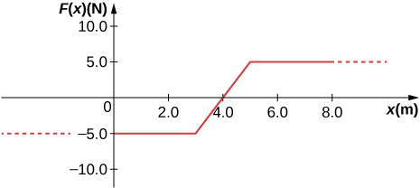

Solution

a. 5.6 m/s; b. 5.2 m/s; c. 6.4 m/s; d. no; e. yes

1. A particle of mass 0.50 kg moves along the *x*-axis with a potential energy whose dependence on *x* is shown below. (a) What is the force on the particle at  12 m? (b) If the total mechanical energy *E* of the particle is –6.0 J, what are the minimum and maximum positions of the particle? (c) What are these positions if  (d) If , what are the speeds of the particle at the positions listed in part (a)?

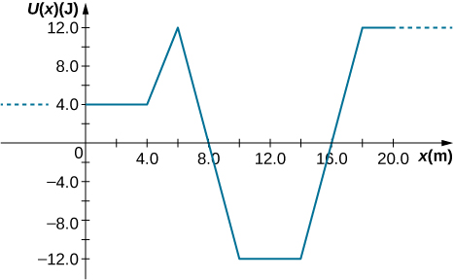

Solution

a. 0 N, -4 N, 6 N, 0 N; b. 9 m and 15 m; c. 7.5 m, 16.5 m; d. 6.9 m/s, 5.7 m/s, 8 m/s, 10.6 m/s

1. (a) Sketch a graph of the potential energy function  where  are constants. (b) What is the force corresponding to this potential energy? (c) Suppose a particle of mass *m* moving with this potential energy has a velocity  when its position is . Show that the particle does not pass through the origin unless

.

Solution

a. 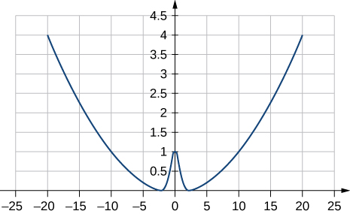

where ; b. ; c. The potential energy at  must be less than the kinetic plus potential energy at  or  Solving this for *A* matches results in the problem.

1. In the cartoon movie: *Pocahontas*, Pocahontas runs to the edge of a cliff and jumps off, showcasing the fun side of her personality. (a) If she is running at 3.0 m/s before jumping off the cliff and she hits the water at the bottom of the cliff at 20.0 m/s, how high is the cliff? Assume negligible air drag in this cartoon. (b) If she jumped off the same cliff from a standstill, how fast would she be falling right before she hit the water?

Solution

a. 20.0 m; b. 19.8 m/s

1. In the reality television show “Amazing Race”, a contestant is firing 12-kg watermelons from a slingshot to hit targets down the field. The slingshot is pulled back 1.5 m and the watermelon is considered to be at ground level. The launch point is 0.3 m from the ground and the targets are 10 m horizontally away. Calculate the spring constant of the slingshot.

Solution

8700 N/m

1. In the *Back to the Future* movies, a DeLorean car of mass 1230 kg travels at 88 miles per hour to venture back to the future. (a) What is the kinetic energy of the DeLorean? (b) What spring constant would be needed to stop this DeLorean in a distance of 0.1m?

Solution

a. ; b. 

1. In the *Hunger Games* movie, Katniss Everdeen fires a 0.0200-kg arrow from ground level to pierce an apple up on a stage. The spring constant of the bow is 330 N/m and she pulls the arrow back a distance of 0.55 m. The apple on the stage is 5.00 m higher than the launching point of the arrow. At what speed does the arrow (a) leave the bow? (b) strike the apple?

Solution

a. 70.6 m/s; b. 69.9 m/s

1. In a “Top Fail” video, two women run at each other and collide by hitting exercise balls together. If each woman has a mass of 50 kg, which includes the exercise ball, and one woman runs to the right at 2.0 m/s and the other is running toward her at 1.0 m/s, (a) how much total kinetic energy is there in the system? (b) If energy is conserved after the collision and each exercise ball has a mass of 2.0 kg, how fast would the balls fly off toward the camera?

Solution

a. 130 J; b. 7.9 m/s

1. In a Coyote/Road Runner cartoon clip, a spring expands quickly and sends the coyote into a rock. If the spring extended 5 m and sent the coyote of mass 20 kg to a speed of 15 m/s, (a) what is the spring constant of this spring? (b) If the coyote were sent vertically into the air with the energy given to him by the spring, how high could he go if there were no non-conservative forces?

Solution

a. 180 N/m; b. 11 m

1. In an iconic movie scene, Forrest Gump runs around the country. If he is running at a constant speed of 3 m/s, would it take him more or less energy to run uphill or downhill and why?

Solution

Even though he expends the same amount of kinetic energy running up- or downhill, he needs to gain potential energy due to gravity running up hill, so ideally this would take more energy.

1. In the movie *Monty Python and the Holy Grail* a cow is catapulted from the top of a castle wall over to the people down below. The gravitational potential energy is set to zero at ground level. The cow is launched from a spring of spring constant  that is expanded 0.5 m from equilibrium. If the castle is 9.1 m tall and the mass of the cow is 110 kg, (a) what is the gravitational potential energy of the cow at the top of the castle? (b) What is the elastic spring energy of the cow before the catapult is released? (c) What is the speed of the cow right before it lands on the ground?

Solution

a. ; b. ; c. 14 m/s

1. A 60.0-kg skier with an initial speed of 12.0 m/s coasts up a 2.50-m high rise as shown. Find her final speed at the top, given that the coefficient of friction between her skis and the snow is 0.80.

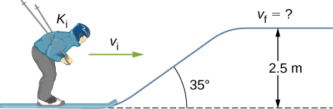

Solution

6.24 m/s

1. (a) How high a hill can a car coast up (engines disengaged) if work done by friction is negligible and its initial speed is 110 km/h? (b) If, in actuality, a 750-kg car with an initial speed of 110 km/h is observed to coast up a hill to a height 22.0 m above its starting point, how much thermal energy was generated by friction? (c) What is the average force of friction if the hill has a slope of  above the horizontal?

Solution

a. 47.6 m; b. ; c. 373 N

1. A subway train is brought to a stop from a speed of 0.500 m/s in 0.400 m by a large spring bumper at the end of its track. What is the spring constant *k* of the spring?

Solution



1. A pogo stick has a spring with a spring constant of  which can be compressed 12.0 cm. To what maximum height from the uncompressed spring can a child jump on the stick using only the energy in the spring, if the child and stick have a total mass of 40 kg?

Solution

33.9 cm

1. A block of mass 500 g is attached to a spring of spring constant 80 N/m (see the following figure). The other end of the spring is attached to a support while the mass rests on a rough surface with a coefficient of friction of 0.20 that is inclined at angle of  The block is pushed along the surface till the spring compresses by 10 cm and is then released from rest. (a) How much potential energy was stored in the block-spring-support system when the block was just released? (b) Determine the speed of the block when it crosses the point when the spring is neither compressed nor stretched. (c) Determine the position of the block where it just comes to rest on its way up the incline.

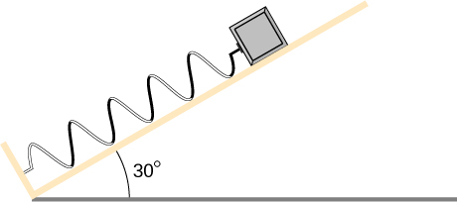

Solution

a. 0.40 J; b. 0.53 m/s. c. 16 cm

1. A block of mass 200 g is attached at the end of a massless spring at equilibrium length of spring constant 50 N/m. The other end of the spring is attached to the ceiling and the mass is released at a height considered to be where the gravitational potential energy is zero. (a) What is the net potential energy of the block at the instant the block is at the lowest point? (b) What is the net potential energy of the block at the midpoint of its descent? (c) What is the speed of the block at the midpoint of its descent?

Solution

a. Zero, since the total energy of the system is zero and the kinetic energy at the lowest point is zero; b.–0.038 J; c. 0.62 m/s

1. A T-shirt cannon launches a shirt at 5.00 m/s from a platform height of 3.00 m from ground level. How fast will the shirt be traveling if it is caught by someone whose hands are (a) 1.00 m from ground level? (b) 4.00 m from ground level? Neglect air drag.

Solution

a. 8.00 m/s; b. 2.32 m/s

1. A child (32 kg) jumps up and down on a trampoline. The trampoline exerts a spring restoring force on the child with a constant of 5000 N/m. At the highest point of the bounce, the child is 1.0 m above the level surface of the trampoline. What is the compression distance of the trampoline? Neglect the bending of the legs or any transfer of energy of the child into the trampoline while jumping.

Solution

42 cm

1. Shown below is a box of mass  that sits on a frictionless incline at an angle above the horizontal . This box is connected by a relatively massless string, over a frictionless pulley, and finally connected to a box at rest over the ledge, labeled . If  and  are a height *h* above the ground and  : (a) What is the initial gravitational potential energy of the system? (b) What is the final kinetic energy of the system, when  hits the ground?

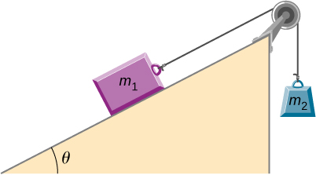

Solution

a. ; b. 

**Additional Problems**

1. A massless spring with force constant  hangs from the ceiling. A 2.0-kg block is attached to the free end of the spring and released. If the block falls 17 cm before starting back upwards, how much work is done by friction during its descent?

Solution

–0.44 J

1. A particle of mass 2.0 kg moves under the influence of the force  Suppose a frictional force also acts on the particle. If the particle’s speed when it starts at  is 0.0 m/s and when it arrives at  is 9.0 m/s, how much work is done on it by the frictional force between  and 

Solution

130 J

1. Block 2 shown below slides along a frictionless table as block 1 falls. Both blocks are attached by a frictionless pulley. Find the speed of the blocks after they have each moved 2.0 m. Assume that they start at rest and that the pulley has negligible mass. Use  and 

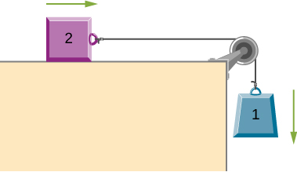

Solution

3.6 m/s

1. A body of mass *m* and negligible size starts from rest and slides down the surface of a frictionless solid sphere of radius *R*. (See below.) Prove that the body leaves the sphere when 

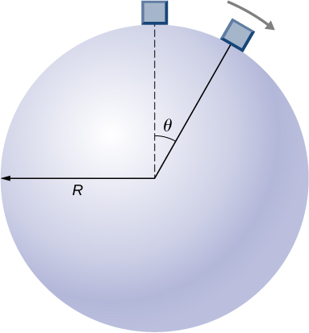

Solution



1. A mysterious force acts on all particles along a particular line and always points towards a particular point *P* on the line. The magnitude of the force on a particle increases as the cube of the distance from that point; that is , if the distance from *P* to the position of the particle is *r*. Let *b* be the proportionality constant, and write the magnitude of the force as . Find the potential energy of a particle subjected to this force when the particle is at a distance *D* from *P*, assuming the potential energy to be zero when the particle is at *P*.

Solution



1. An object of mass 10 kg is released at point *A*, slides to the bottom of the  incline, then collides with a horizontal massless spring, compressing it a maximum distance of 0.75 m. (See below.) The spring constant is 500 N/m, the height of the incline is 2.0 m, and the horizontal surface is frictionless. (a) What is the speed of the object at the bottom of the incline? (b) What is the work of friction on the object while it is on the incline? (c) The spring recoils and sends the object back toward the incline. What is the speed of the object when it reaches the base of the incline? (d) What vertical distance does it move back up the incline?

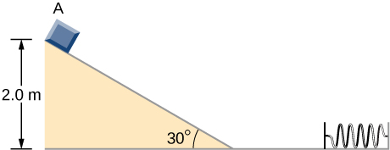

Solution

a. 5.3 m/s; b. 56 J; c. 5.3 m/s; d. 1.3 m

1. Shown below is a small ball of mass *m* attached to a string of length *a*. A small peg is located a distance *h* below the point where the string is supported. If the ball is released when the string is horizontal, show that *h* must be greater than 3*a*/5 if the ball is to swing completely around the peg.

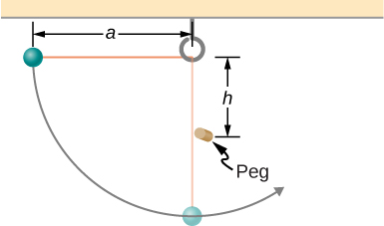

Solution

proof

1. A block leaves a frictionless inclined surfarce horizontally after dropping off by a height *h*. Find the horizontal distance *D* where it will land on the floor, in terms of *h*, *H*, and *g*.

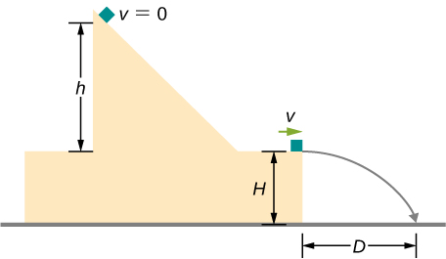

Solution



1. A block of mass *m*, after sliding down a frictionless incline, strikes another block of mass *M* that is attached to a spring of spring constant *k* (see below). The blocks stick together upon impact and travel together. (a) Find the compression of the spring in terms of *m*, *M*, *h*, *g*,and *k* when the combination comes to rest. (*Hint*: The speed of the combined blocks  is based on the speed of block m just prior to the collision with the block  based on the equation  This will be discussed further in the chapter on Linear Momentum and Collisions.) (b) The loss of kinetic energy as a result of the bonding of the two masses upon impact is stored in the so-called binding energy of the two masses. Calculate the binding energy.

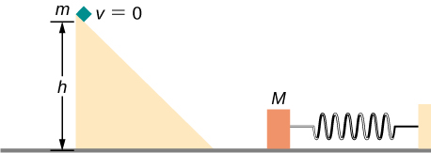

Solution

a. ; b. 

1. A block of mass 300 g is attached to a spring of spring constant 100 N/m. The other end of the spring is attached to a support while the block rests on a smooth horizontal table and can slide freely without any friction. The block is pushed horizontally till the spring compresses by 12 cm, and then the block is released from rest. (a) How much potential energy was stored in the block-spring support system when the block was just released? (b) Determine the speed of the block when it crosses the point when the spring is neither compressed nor stretched. (c) Determine the speed of the block when it has traveled a distance of 20 cm from where it was released.

Solution

a. 0.72 J; b. 2.2 m/s; c. 1.6 m/s

1. Consider a block of mass 0*.*200 kg attached to a spring of spring constant 100 N/m. The block is placed on a frictionless table, and the other end of the spring is attached to the wall so that the spring is level with the table. The block is then pushed in so that the spring is compressed by 10.0 cm. Find the speed of the block as it crosses (a) the point when the spring is not stretched, (b) 5.00 cm to the left of point in (a), and (c) 5.00 cm to the right of point in (a).

Solution



1. A skier starts from rest and slides downhill. What will be the speed of the skier if he drops by 20 meters in vertical height? Ignore any air resistance (which will, in reality, be quite a lot), and any friction between the skis and the snow.

Solution

20 m/s

1. Repeat the preceding problem, but this time, suppose that the work done by air resistance cannot be ignored. Let the work done by the air resistance when the skier goes from *A* to *B* along the given hilly path be –2000 J. The work done by air resistance is negative since the air resistance acts in the opposite direction to the displacement. Supposing the mass of the skier is 50 kg, what is the speed of the skier at point *B*?

Solution

18 m/s

1. Two bodies are interacting by a conservative force. Show that the mechanical energy of an isolated system consisting of two bodies interacting with a conservative force is conserved. (*Hint*: Start by using Newton’s third law and the definition of work to find the work done on each body by the conservative force.)

Solution

Proof

1. In an amusement park, a car rolls in a track as shown below. Find the speed of the car at *A*, *B*, and *C*. Note that the work done by the rolling friction is zero since the displacement of the point at which the rolling friction acts on the tires is momentarily at rest and therefore has a zero displacement.

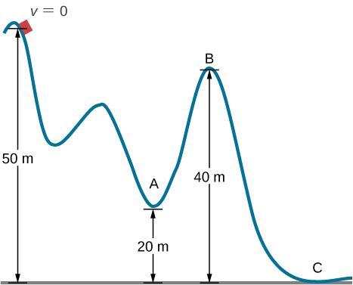

Solution



1. A 200-g steel ball is tied to a 2.00-m “massless” string and hung from the ceiling to make a pendulum, and then, the ball is brought to a position making a  angle with the vertical direction and released from rest. Ignoring the effects of the air resistance, find the speed of the ball when the string (a) is vertically down, (b) makes an angle of  with the vertical and (c) makes an angle of  with the vertical.

Solution



1. A 300 g hockey puck is shot across an ice-covered pond. Before the hockey puck was hit, the puck was at rest. After the hit, the puck has a speed of 40 m/s. The puck comes to rest after going a distance of 30 m. (a) Describe how the energy of the puck changes over time, giving the numerical values of any work or energy involved. (b) Find the magnitude of the net friction force.

Solution

a. Loss of energy is ; b. 

1. A projectile of mass 2 kg is fired with a speed of 20 m/s at an angle of  with respect to the horizontal. (a) Calculate the initial total energy of the projectile given that the reference point of zero gravitational potential energy at the launch position. (b) Calculate the kinetic energy at the highest vertical position of the projectile. (c) Calculate the gravitational potential energy at the highest vertical position. (d) Calculate the maximum height that the projectile reaches. Compare this result by solving the same problem using your knowledge of projectile motion.

Solution

a. 400 J; b. 300 J; c. 100 J; d. 5.1 m which should match solving the same problem using projectile motion

1. An artillery shell is fired at a target 200 m above the ground. When the shell is 100 m in the air, it has a speed of 100 m/s. What is its speed when it hits its target? Neglect air friction.

Solution

89.7 m/s

1. How much energy is lost to a dissipative drag force if a 60-kg person falls at a constant speed for 15 meters?

Solution



1. A box slides on a frictionless surface with a total energy of 50 J. It hits a spring and compresses the spring a distance of 25 cm from equilibrium. If the same box with the same initial energy slides on a rough surface, it only compresses the spring a distance of 15 cm, how much energy must have been lost by sliding on the rough surface?

Solution

32 J

This file is copyright 2016, Rice University. All Rights Reserved.